**Maths Homework helper** [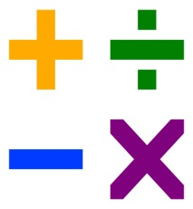](http://www.clipartpanda.com/clipart_images/and-multiplication-4159444)

**The purpose of this letter is so that you can help your child with their maths work at home and understand the methods of the four operations, (addition, subtraction, multiplication and division) that the children are using in school.**

**Addition +**

When the children are confident in using practical resources and numbered number lines to add numbers together, the children will then begin to use ‘empty number lines’ starting with the larger number and counting on

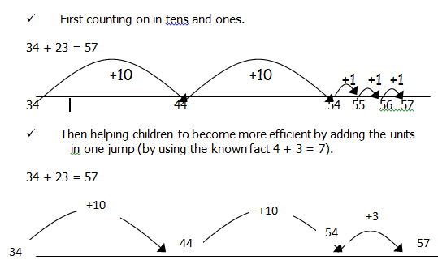

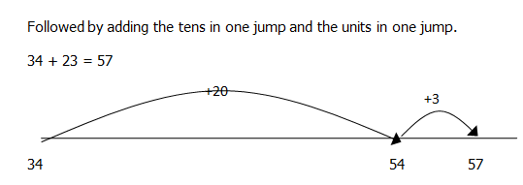

**Subtraction ­-**

As with addition, when the children are confident in using practical resources to take one amount from another, and can use a numbered number line to count back and to find the difference between two numbers, then the children will begin to use empty number lines.

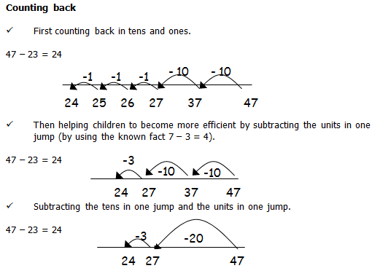

**Multiplication ×**

Children will experience equal groups of objects and will count in steps of 2, 3, 5 and 10. Children will develop their understanding of multiplication and use jottings to support calculation.

Repeated addition

3 times 5 is 5 + 5 + 5 =15

or 3 lots of 5

or 3 x 5

Counting in multiples of 5 to find the answer

Arrays - Children model a multiplication calculation using an array

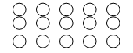

5 × 3 = 15 5 lots of 3 = 3 + 3 + 3 + 3 + 3 3 × 5 = 15 3 lots of 5 = 5 + 5 + 5

Division ÷

Children will count in steps of 2, 3, 5 and 10.

Children will develop their understanding of division and use jottings to support the calculation.

8 ÷ 2 =

Count out 8

Then make groups of 2 (÷2) 4 groups 8 ÷ 2 = 4

Counting in multiples of 2 to find the answer.

How many 2’s in 8?

Sharing equally

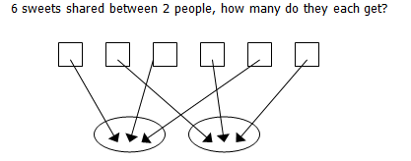

6 ÷ 2 = 3

We hope that this information about the different methods for the four operations ( +, -, ×, ÷)

helps you to understand how your child approaches number tasks in school.

If you have any further questions, please don’t hesitate to ask.

Many thanks

Mrs N. Manley