**Geography/Science** — Our topic this half term will heavily focus around the importance of recycling and what impact it is having on the environment. We will look at plastic pollution, our local environment and how we can be more eco-friendly and the types of materials things are made from.

**In-reach Activity**- Renewi Workshop in school onWednesday 18th September.

**Enrichment-** After lunch on Wednesday and Friday, Year 2 pupils will be involved in a whole afternoon of activities designed to enrich the curriculum. They will have PE with First Steps and RE and Music with Mrs Alonso

**PE days**

**Wednesday and Friday**

**Please ensure children have both their indoor and outdoor kits at all times**

**Design & Technology** — In D&T we will be designing and making products out of recyclable materials.

**ICT**— In ICT we will be programming using the turtle program. Children will give the turtle commands to draw regular polygons.

**Half termly Homework Project**

**Litter Bug**

This half terms project will be about recycling. During the holidays we would like you and your child to craft something out of recyclable materials for our display.

Here are a few ideas:

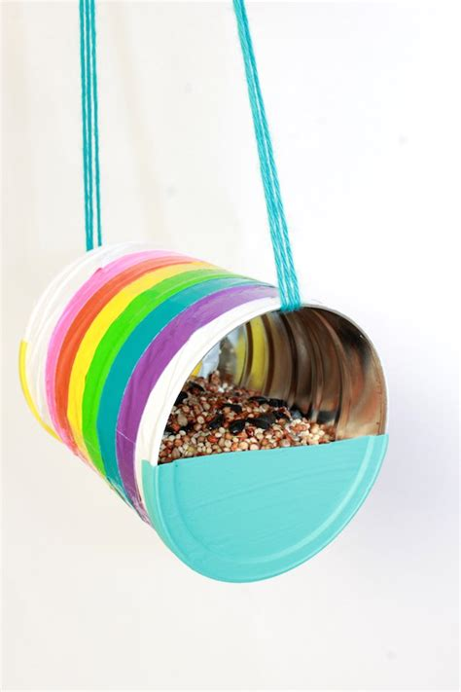 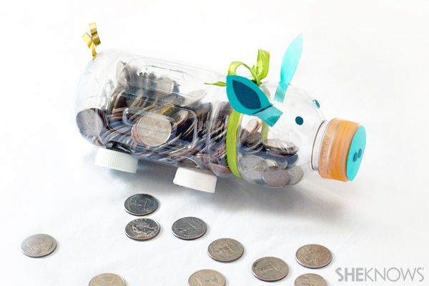

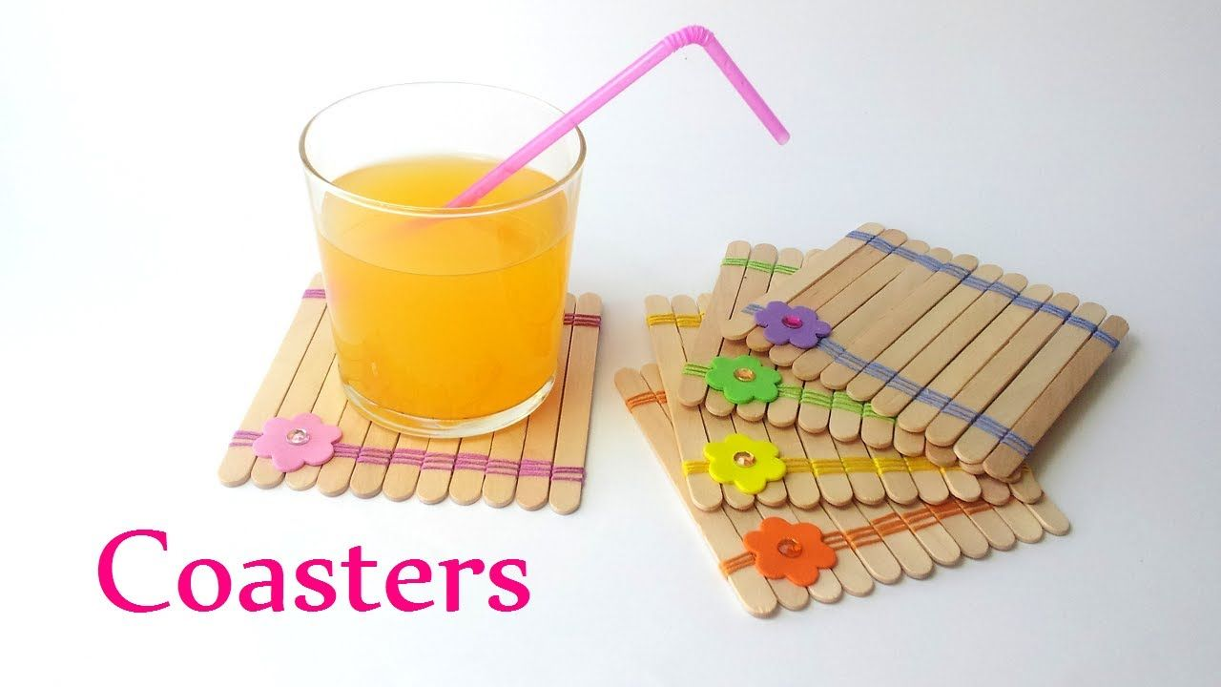 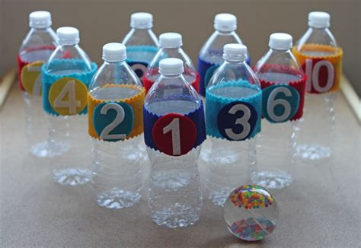

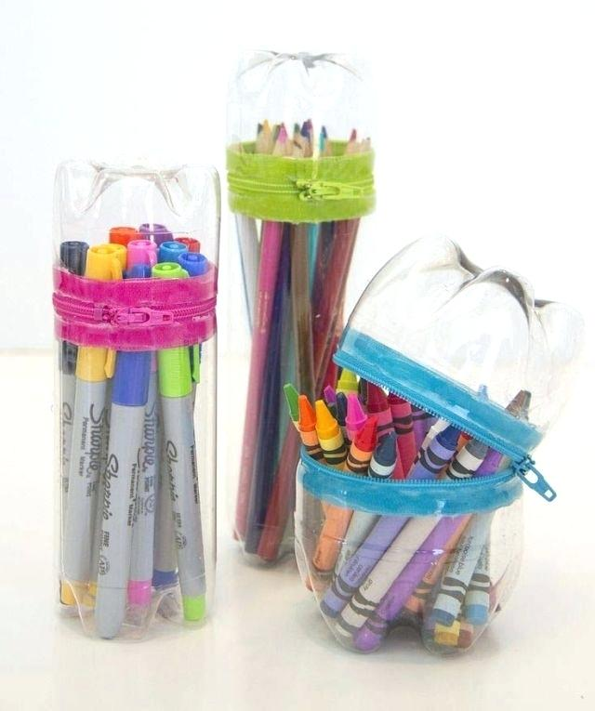

**Maths**—We will be having

regular ‘Mental Maths’ sessions as well a weekly Two Minute Mental Maths

Challenge and continue our times table challenges.

Our Maths this half term will cover: Place value, addition, subtraction, money, shape and statistics.

**English—**This half term, our English lessons will consist of imaginative writing linked to a narrative called Michael Recycle, instructional writing and poetry.